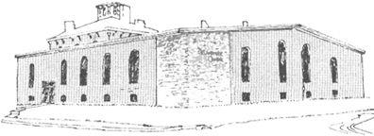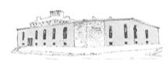

****

Pastor James Reynolds, Sr.

Asst. Pastor Stephen G. Reynolds, Sr.

1008 Congress St. Portland, ME 04102

Tel. (207) 774-8192

[www.**thedeliverancecenter**.com](http://www.thedeliverancecenter.com)

*From the Desk of Pastor Stephen Reynolds, Sr.*

Dear , Brother Mathew

Let Him help you; He asked you to help him, enjoy the memory for a long time, the Lord willing and the Lord tarrying.

Sincerely,

Stephen G. Reynolds, Sr.

Assistant Pastor